As highlighted in our previous blog: “10 Common Pitfalls That Lead To Construction Disputes”, construction projects are highly complex undertakings with many potential pitfalls that can lead to disputes, delays, cost overruns and financial losses if not carefully managed.
That’s why having tight control of the commercials from start to finish is absolutely critical to the overall success and profitability of any construction project.
At Nexus Consult, we understand the importance of getting the commercial management of the project right from day one. We work closely with our main contractor and specialist subcontractor clients to ensure they navigate complex financial and contractual issues, avoid costly mistakes, achieve greater success on their projects and help ensure achievable budgets and contracts are in place that position projects for success before work even begins on site.
Our hands-on approach sees our experienced quantity surveyor’s, led by director Scott Coulton, embedded within your project teams, taking commercial responsibility for the financial control of the project.
We focus on minimising costs, mitigating risks, enhancing value and increasing profits for our clients through proactive commercial management and oversight.

Proactive Commercial Management Safeguards Profit
Nexus believes that the key focus should be on proactive commercial management that controls costs, mitigates risks, resolves issues quickly and maximises our client’s entitlement – rather than reactive firefighting and disputes occurring further down the line, which can prove incredibly costly.
From contract award, good commercial managers will provide continuous objective oversight and monitoring to proactively safeguard profitability, including:
- Review of contracts to identify your obligations, weed out unfavourable terms and create a robust base and strategy for the project to move forward.
- Robust change management processes to control variations and maintain cost/value certainty.
- Comprehensive cost reporting, financial monitoring, and cash flow projections
- Stringent contractual compliance for payments, applications, notices, and final accounts
- Early flagging and resolution of any issues before they needlessly escalate to dispute
- Placing your project commercials in a strong position, whilst actively maintaining collaborative relationships with your client.

Our Service Offerings
At Nexus Consult, we understand that the needs of main contractors and subcontractors differ. We work hands-on providing commercial and contract management take commercial responsibility for our clients projects or we will ensure our clients have efficient commercial processes in place, manage and mentor their QS’s and validate the commercial and contract decisions that their businesses needs to make.
With three core focuses: Commercial & Contract Management, Cost & Profit Management, Maximising Entitlement, we ensure our clients have the tools and strategy to start projects on the best contract terms for their business; understand their contractual obligations, mitigate commercial impacts, and deliver profitable projects from a position of strength.
Our approach has proven to manage commercial performance and deliver profitable projects.
Here are the typical tasks that each core covers:
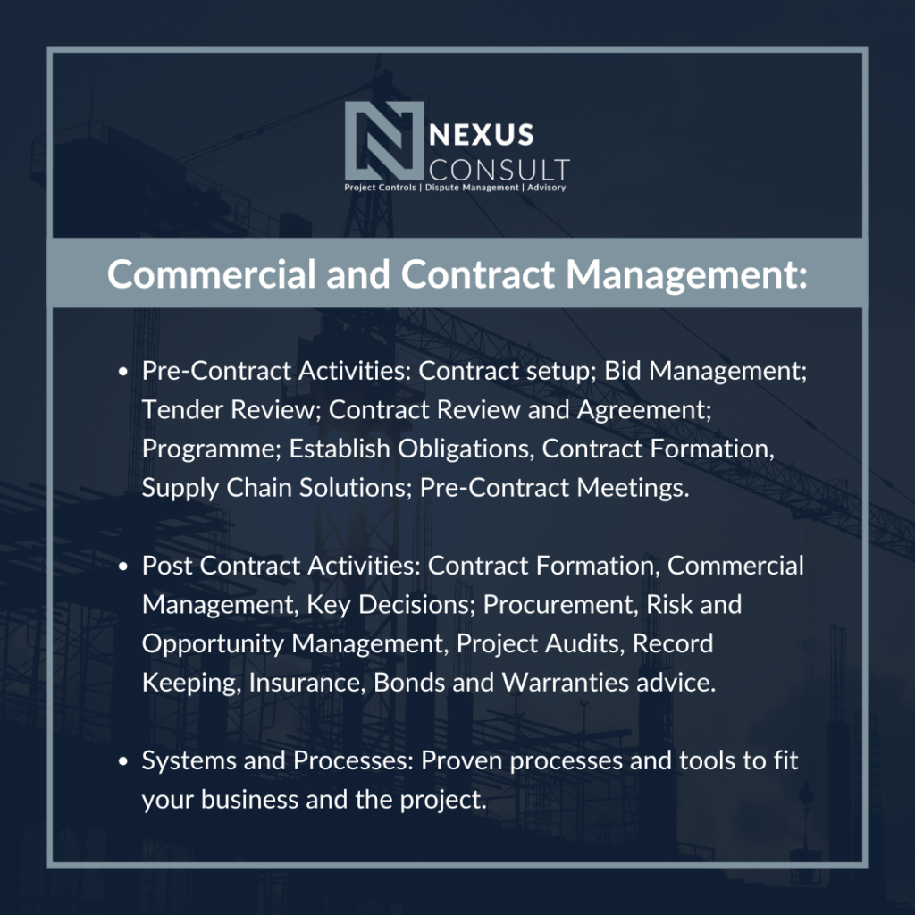
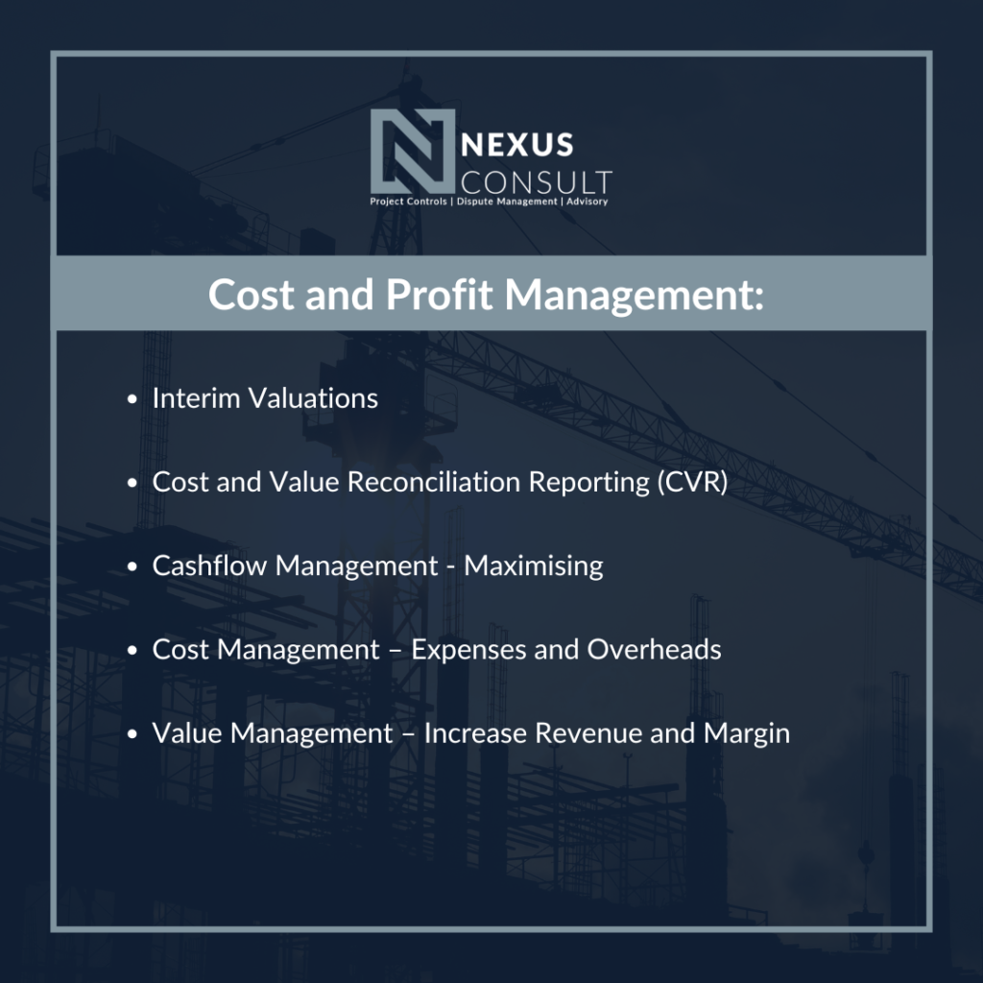
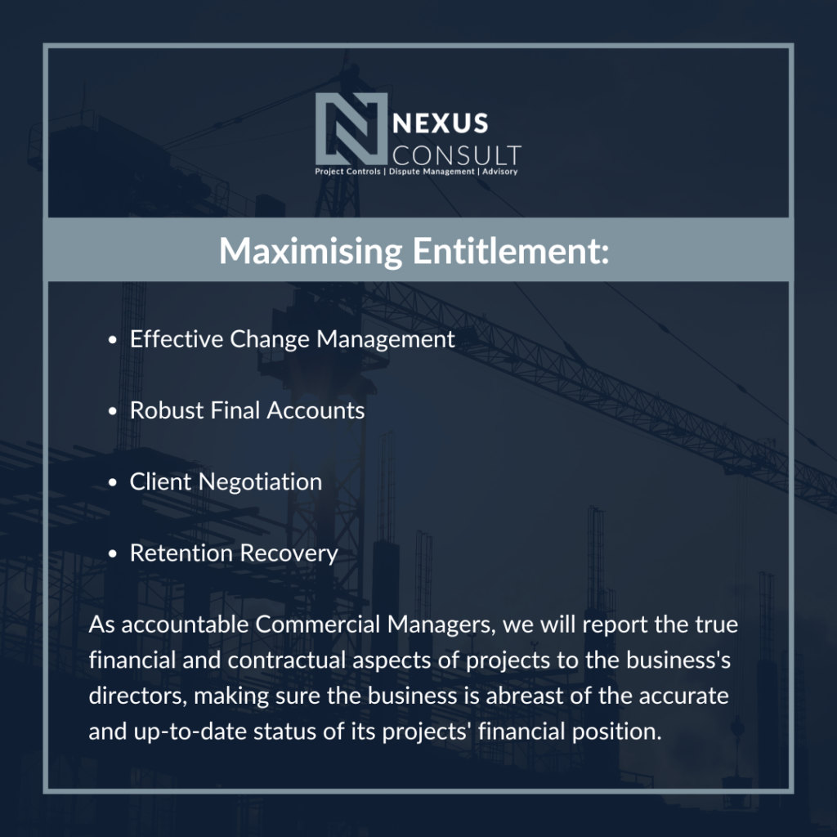

The Benefits of Partnering with Nexus
By partnering with Nexus Consult, you gain a trusted and experienced advisor dedicated to your project’s success, regardless of our role. Our commercial management expertise empower you to maximise profitability. We don’t just manage costs; we identify opportunities to add value throughout the construction process.
Don’t leave the commercial success of your project to chance.
Contact Nexus Consult today to discuss how our tailored commercial management services can safeguard your profitability and enhance project value.

